Monster Instructions

Version: V5.0.4

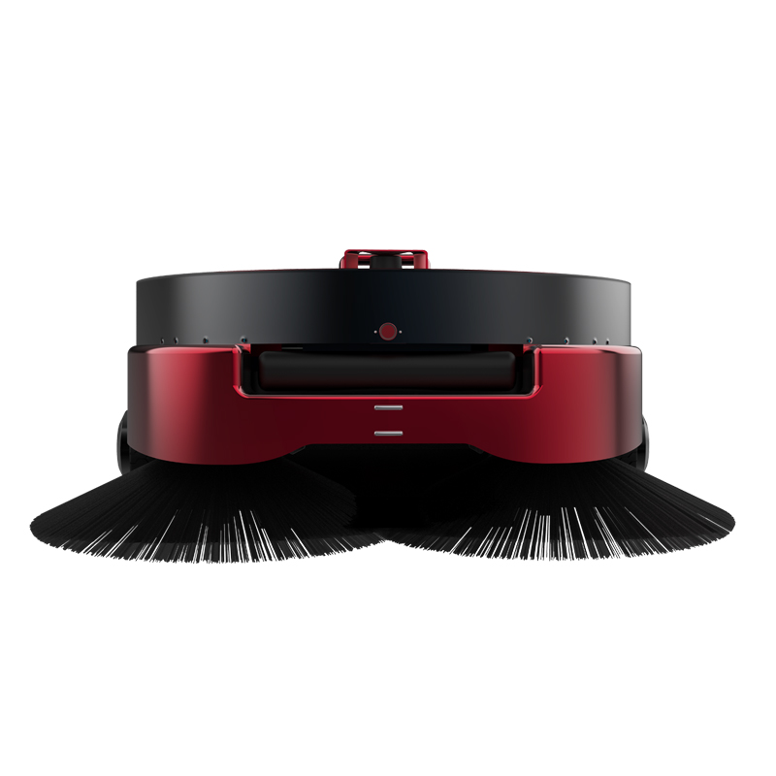

Note: This document provides machine-related deployment procedures and precautions. Following the usage instructions in the document can avoid other abnormal situations when using the machine later.
Table of contents
1. Introduction to robots 3
Usage environment requirements 3
Charging precautions 4
Hardware parameters 5
Get to know your robot 9
2. Use your robot 10
A. Start up 10
B. Charging 11
C. Navigation deployment 13
Step 1 [Network Settings] 14
Step 2[Build Map] 18
Step 3 [Edit Cleaning Area] 23
Step 4 [Edit Virtual Wall] 23
Step 5 [Calibrate position] 26
Step 6[Cleaning along the edge] 28
D. Start cleaning tasks 29
1. Setup instructions 30
2. Cleaning plan setting 31
3. Swipe right to open the settings interface 32
4. Start manual cleaning 33
3. Explanation of other functions 34
a[Modify Map] 34
b[Map Management] 35
c[Upgrade] 36
d[Settings] 37
4. Daily maintenance of robots 37
5. Precautions for daily use 39
① Machine positioning is lost 39
② The machine does not navigate 40
③ The machine navigation does not respond when charging. 41

1. Introduction to robots

Usage environment requirements
Please use this product in accordance with the instructions in the manual. Any losses caused by improper use will be borne by the user.

- Do not use immediately after an extreme temperature change, such as moving from a cold outside to a warm room.
- Do not use it in flammable, explosive environments or near heat sources.
- Do not leave the robot in direct sunlight for a long time.
- the robot's operating area should be solid, smooth, and flat. It is not recommended to use it on soft or ridged ground or outdoors. This will reduce the performance of the robot or cause the risk of the robot falling.
( Since the robot can move autonomously and complete various actions, please pay special attention: Do not move on sloped ground to prevent accidental dumping of the robot or uncontrolled operation causing personal injury, damage to the robot, and damage to equipment, facilities, and items. Damage , if moving on a sloping road, special care is required )
- Please pay attention to the location where there are stairs or steps, and avoid the robot moving in this area to prevent it from falling or falling.
- When using all-glass doors or all-glass walls, be sure to paste safety and visible signs between the glass and the ground 22cm-25cm away . Personnel (especially children) should keep a safe distance from the robot (more than 1 meter away from the robot) to prevent Personal injury or damage to the robot caused by the operation of the robot
- Do not trip, drop, squeeze, bend, poke, cut, microwave, burn or paint this robot and parts
- Please do not attempt to disassemble the robot and its accessories. Disassembly can only be performed by authorized professionals.
- Do not apply excessive pressure on the screen and device to avoid damage, and only use your fingers to interact with the touch screen
- To ensure the reliability of this product and the safety of operation, please be sure to use exclusive accessories for this robot
- Avoid obstacles that are too low (the height of obstacles shall not be lower than the installation position of the ultrasonic sensor and laser sensor, and shall not be lower than 25cm)
- Avoid environments with a drop greater than 5cm such as escalators, stairs, steps, etc.

Charging precautions
- Please use a power supply with proper grounding that complies with local regulations and the requirements of this manual, otherwise it will cause electric shock to personnel and damage to the robot.
- Personnel are prohibited from touching or operating the robot while it is charging.
- Do not drop or hit the charging station
- Do not touch the power cord with wet hands or pull out the charging pile by pulling on the power cord.
- Prevent the charging pile from being exposed to rain, liquid, or moisture
- If you do not use the robot for a long time, it is recommended that you charge it every 15 days or so to ensure that the battery is always in the best state of activity.
- Do not use the battery with other devices
- Do not try to touch the charging pile and the charging port output of the robot. There may be certain risks.
- The charging pile layout area must be against the wall and open within a radius of 2 meters.
※ Special attention: Improper operation of the battery may cause battery explosion, fire, leakage, corrosion and other accidents.

Hardware parameters
Hardware parameters | Index performance
product specifications
Product Size | Length 730mm * Width 690mm * Height 325 mm
product weight | 40kg
Product color | red black
product material | sheet metal
Environmental requirements | Storage temperature: -15°C~55°C; Working temperature: 0°C ~ +50°C Humidity (RH): 10%~90%
Android specifications
operating system | Android 5.1
language support | Chinese
Processor type | RK3128
Memory LPDDDR3 | 1G
Built-in NAND FLASH | 8GB
USB debugging port | Micro USB interface
Display | 7-inch, IPS screen (16:9) resolution 1024X600
External I/O port | 1 USB 2.0 (MICROUSB), RJ45 network port
speaker | 4Ω/3W mono speaker
Wireless Technology AP6255 | Support dual-band 2.4&5G  WIFI 802.11b/g/n wireless LAN,  11ac 5.15GHz-5.825GHz
ROS Navigation Specifications
operating system | LINUX
lidar | Laser wavelength 905 nm working area 270°
Single axis gyro sensor | Yaw angle measurement
harddisk | 128G high-speed solid state drive, 8G memory stick
motor driven | 5.5 inch hub motor
Infrared sensor | Communicates with charging piles within 1 meter
512AN_HMW module Intel WIFI | Support dual-band 2.4&5G  WIFI&BT4.1 802.11b/g/n wireless LAN  11ac 5.15GHz-5.825GHz
Moving speed | Minimum 0.1 m/s, maximum 0.5 m/s
Navigation board | Intel I5 10th generation motherboard
Sensor configuration | Lidar attitude sensor
Side brush
Side brush | 500mm
Cleaning width | 890mm
Cleaning efficiency | Maximum 1000m/h
roller brush
roller brush | 400mm
dust box
volume | 30L
Power Systems
Motor | Side brush motor, roller brush motor
charging method | Automatic recharge
adapter | Input: AC110-240V.50-60HZ  Output: DC43.2V-6.5A
Robot input power | 43.2V--6.5A
Battery | 25AH lithium iron phosphate, 38.4V/960W
Charging pile parameters | Overcurrent protection, intelligent power off, output rated voltage: 43.2V, output rated current: 6.5A
Charging time | 4-5 hours
Battery life | 9-10 hours

Get to know your robot
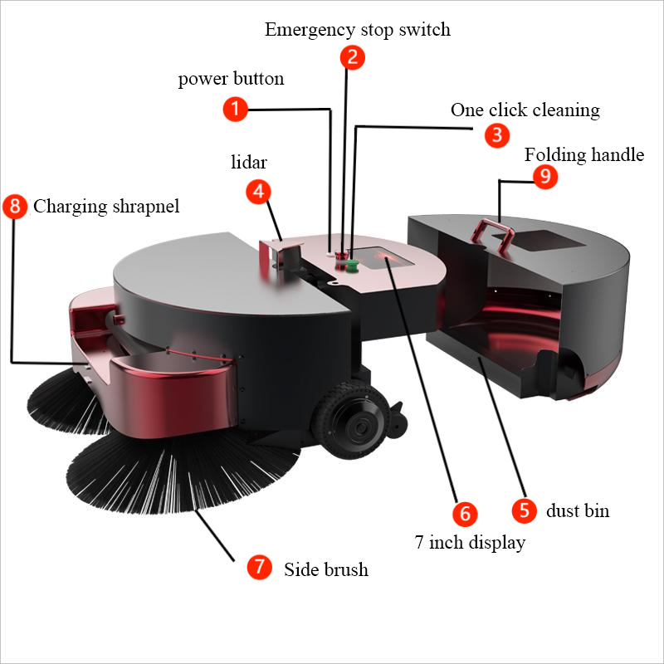
- power button
- Emergency stop switch
- One click cleaning
- lidar
- dust bin
- 7 inch display
- Side brush
- Charging shrapnel
- Folding handle
- Hidden railing
- roller brush
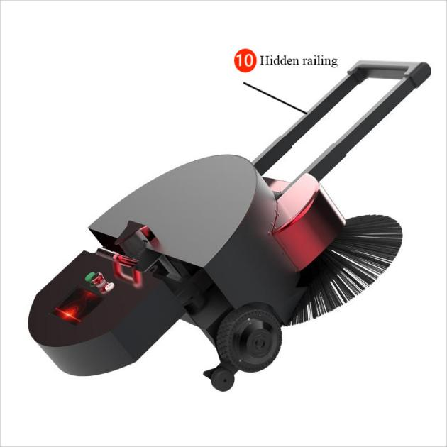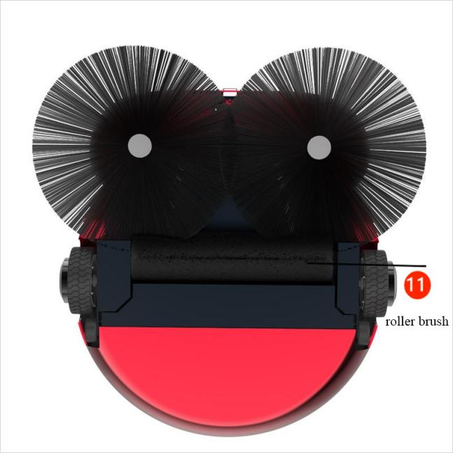
Cleaning precautions: ⑥ touchscreen​ ④Laser navigation cannot be wiped with a wet towel to avoid water intrusion!
Precautions for use: ④ Laser: Never block the laser with objects
② Emergency stop switch : The emergency stop switch can only be rotated to the right, never to the left.

2. Use your robot

A. Start up
The power button is located on the robot① , is a key switch. Press once to turn on the phone, and press and hold the power button for 3 seconds to turn off .
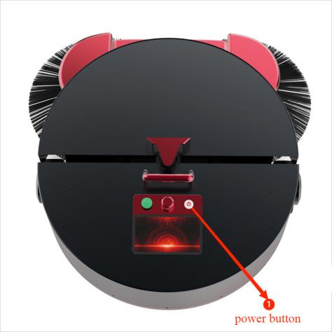
Precautions for shutting down : Press and hold the power button for 3 seconds . The display will first turn off and shut down , then the motor will lose power, and eventually the machine light will go out !

B. Charging
Get to know your charger
You need to plug the adapter plug into a voltage of 110-220 V , and plug the DC plug into the automatic charging pile. At this time, the green light of the charging pile will light up , indicating that it is ready to charge .
① Manual charging: Push the robot onto the charging pile so that the charging pad behind the robot is in full contact with the charging pad on the charging pile . The charging pile indicator light turns red to indicate that the machine is charging.
② Automatic charging: Refer to the navigation deployment below, arrange the charging pile points, open the [Monster Robot] application on the Android screen, and customize the power value that triggers automatic recharge
Automatic charging: The robot can automatically detect the power and charge automatically when the power is lower than the set threshold (prerequisite: a map needs to be constructed to mark the charging pile points. The calibration method is as shown in the schematic diagram below )
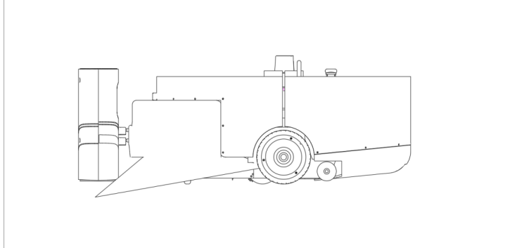

Automatic charging hardware instructions
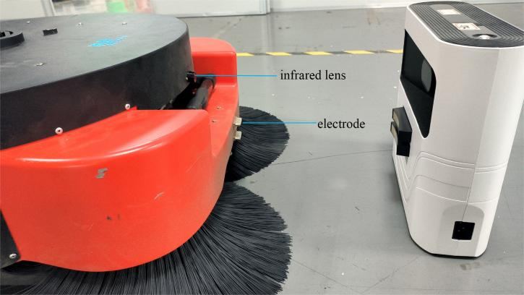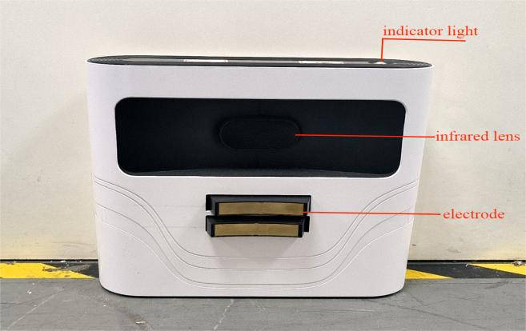

Charging pile location placement
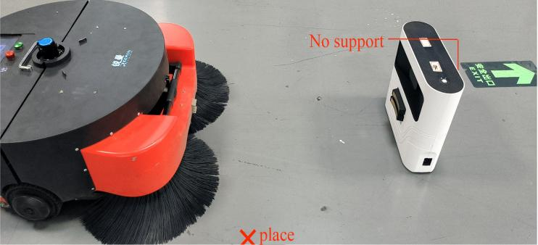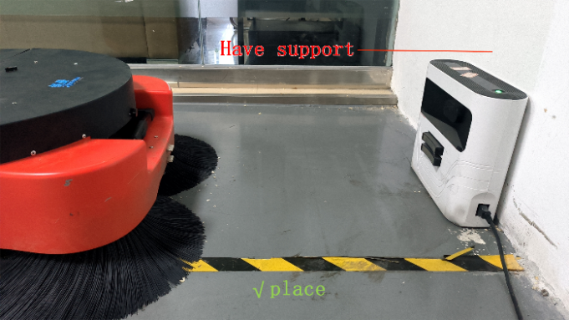
Charging pile location selection and precautions
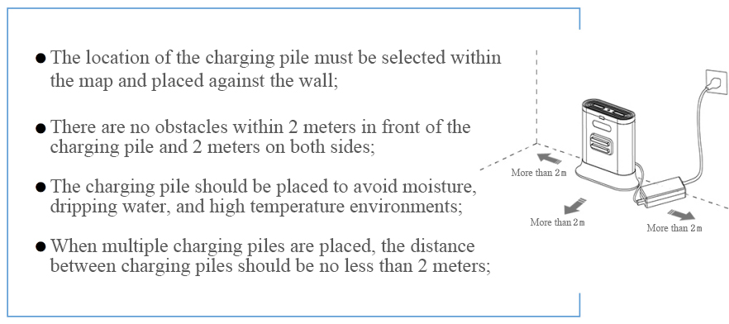

C. Navigation deployment
Note: The following content is an introduction to all functions of the robot deployment background. The functions that must be operated are points 1, 2, 3, 4, and 5 in the figure below. Other functions depend on the specific scenario and usage.
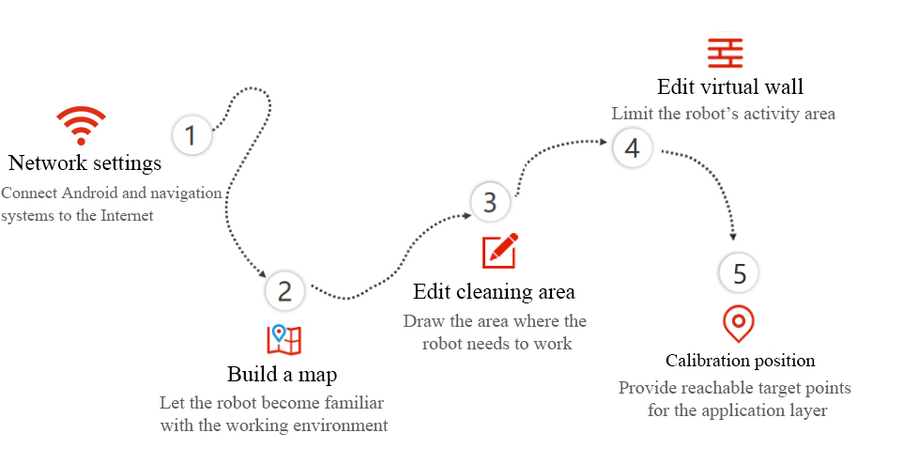

Step 1 [Network Settings]
Note: The router network segment cannot be the 192.168.10.x network segment
- Open "Settings" on the Android screen of the robot - "WLAN" to connect to Wi-Fi
- Open the aging-ros3 application and enter the following interface, follow the steps shown in the figure. If the Wi-Fi password already exists, just click "OK". (The picture below is an example picture)
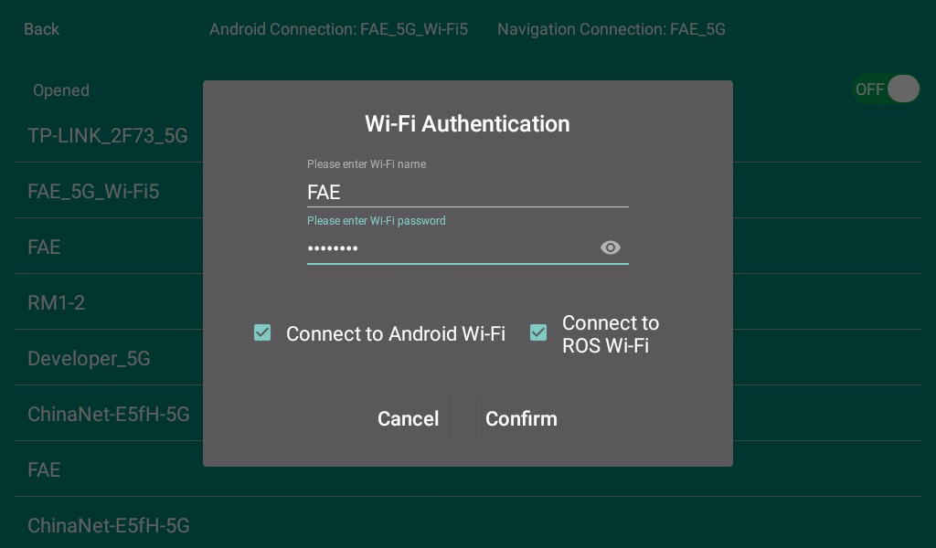
- Check the Wi-Fi name to connect to
- Enter Wi-Fi password
- Send Wi-Fi information to the navigation system (just click once, do not click repeatedly)
- If the IP is displayed, the connection is successful (if 127.0.0.1 is displayed, the connection fails)
- The scanning device needs to be connected to the same LAN as the machine. Open the browser and enter the machine IP address (chrome browser is recommended)
If the connection to Wi-Fi fails, you can click "OK" again to reconnect. If it still fails, you can change the network to connect.
- Hotspot connection method
- Turn on the mobile hotspot, as shown in the figure：
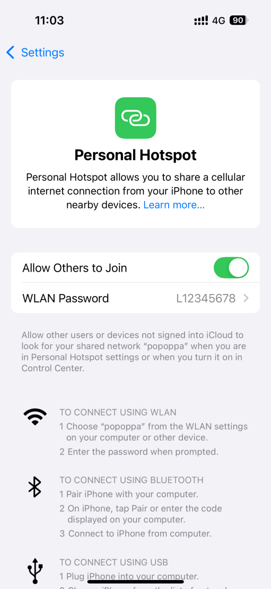
- Open the network settings on the robot software, find the name of the mobile hotspot and click it, as shown in the figure:
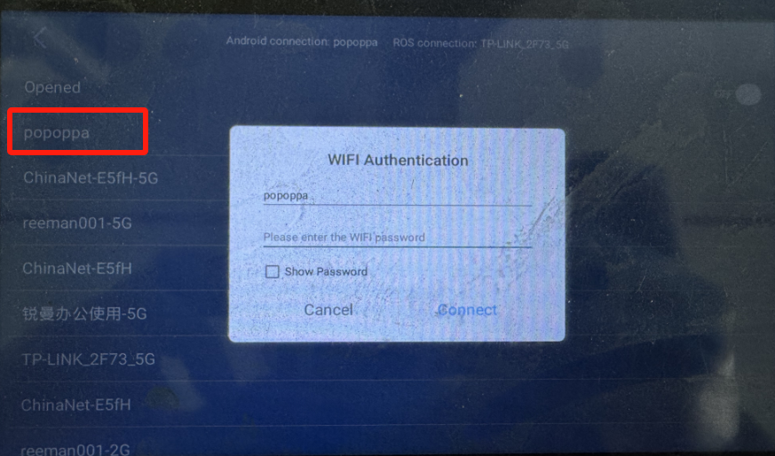
(3)After clicking the mobile hotspot name, enter the mobile hotspot password, and then click Connect:
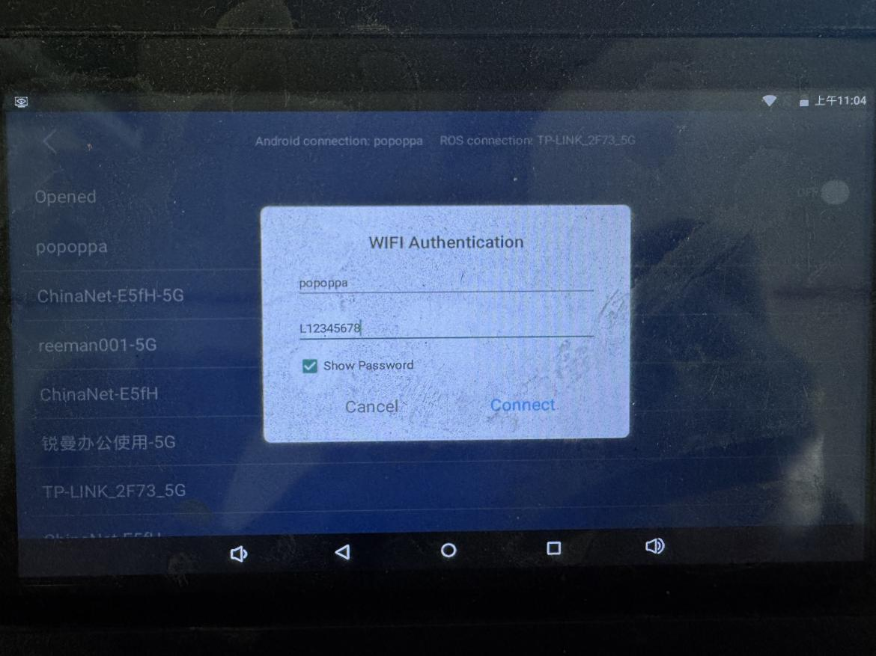
- After the connection is successful, the ros IP address will be displayed on the software:
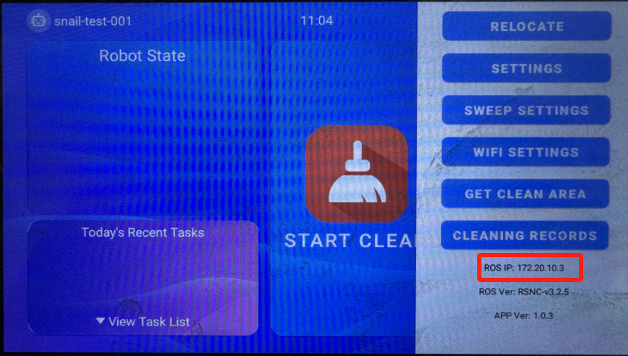

- Connect the computer to the mobile phone hotspot as shown in the figure:
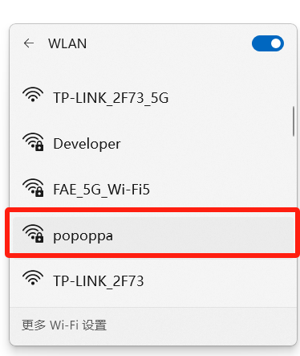
- Open the Google Chrome or any other browser on your computer, enter the ros ip (point 5) on the robot into the browser, and you can enter the robot map page:
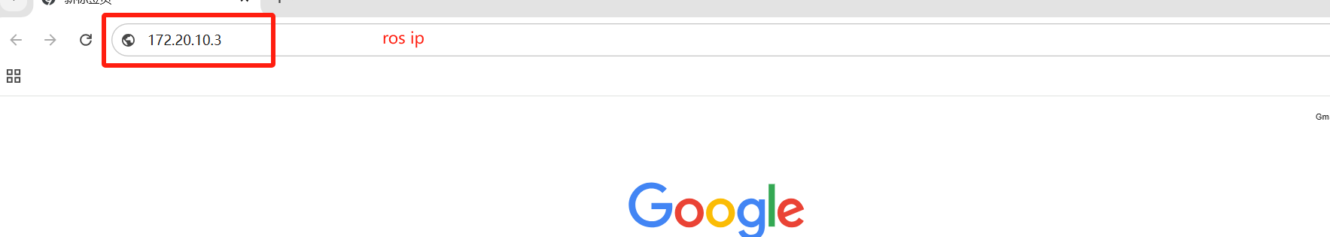

Step 2[Build Map]
- The purpose of building a map is to allow the robot to understand the working environment
- The robot needs to scan the actual environment and build an "original map". During the navigation process, the machine can compare the real-time scan with the original map to find its own position.
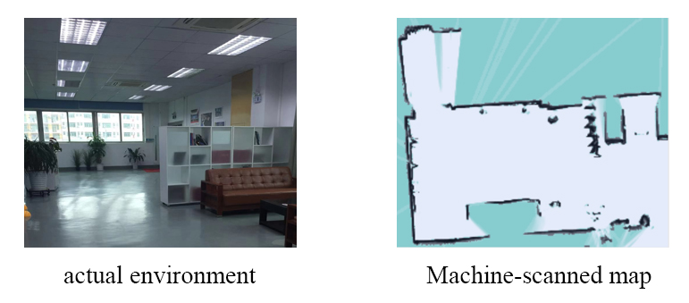
- It is required to turn the emergency stop switch of the machine by turning it to the right, and use the keyboard direction keys to control the machine to build the map.
- The radar's field of view is 270°, and the scanning range is the horizontal plane at the height of the radar; the scanning distance is 20 meters.
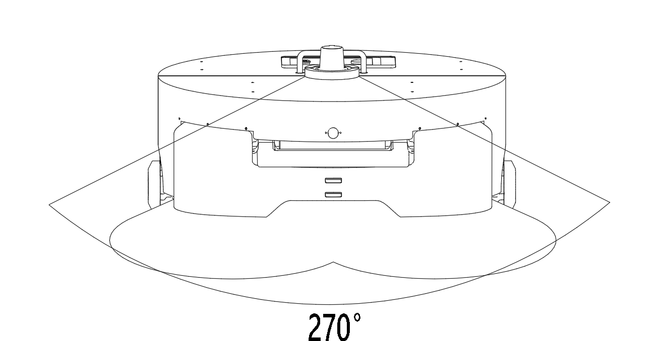

- After entering the web page, the default state is "Navigation Mode", click to switch to "Mapping Mode", select 'Build mode' and enter the state as shown below to start scanning.
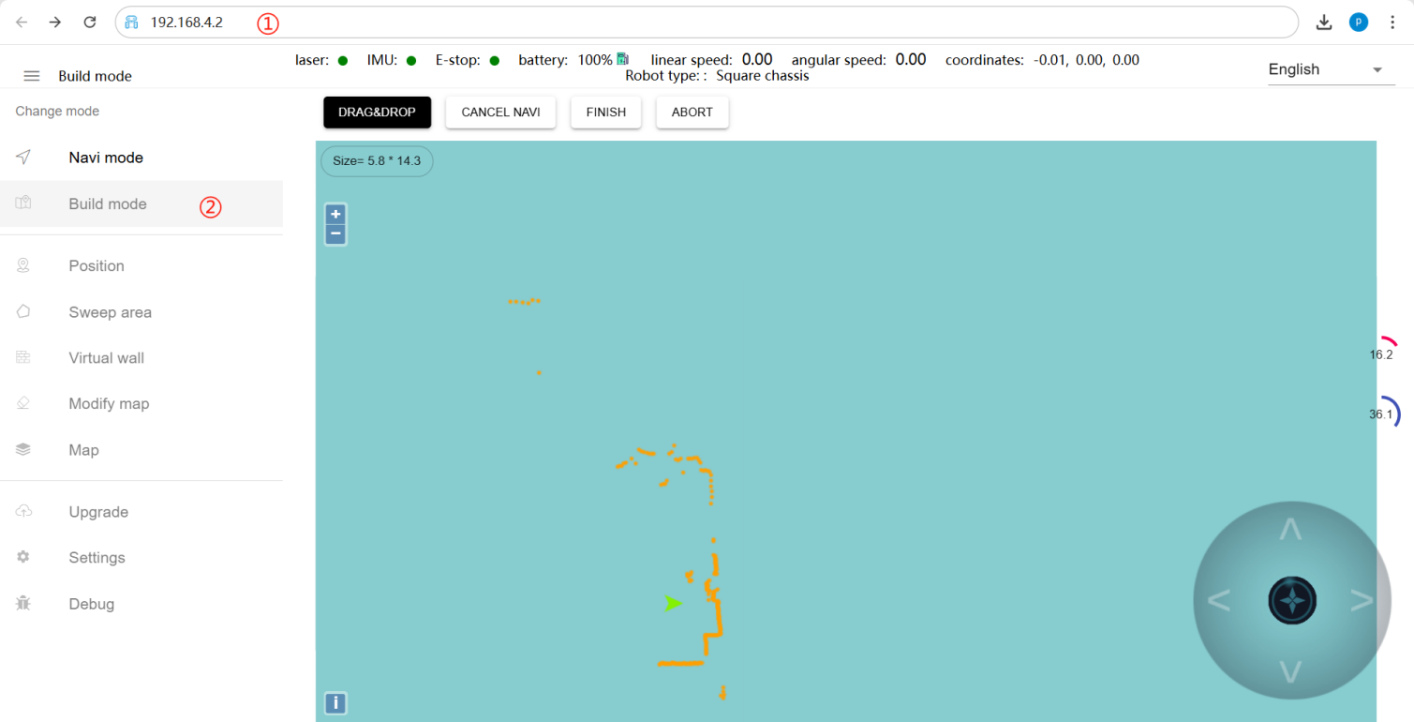
①Obtain IP from aging-ros3 software
②Switch to mapping mode and select 'Laser Mapping'
- After entering the "mapping mode", the machine first rotates in place to clear out the surrounding feature points. When rotating, the speed should not be too fast. After completing the rotation, the machine can be controlled to move. You can walk in a straight line in a narrow area. When walking, you need to pay attention to where there are gaps. Slowly turn the machine 90° on the spot to face the gaps to clear out the characteristic points, and then slowly turn back to continue scanning. In open areas, you can follow a U-shaped route, as follows:

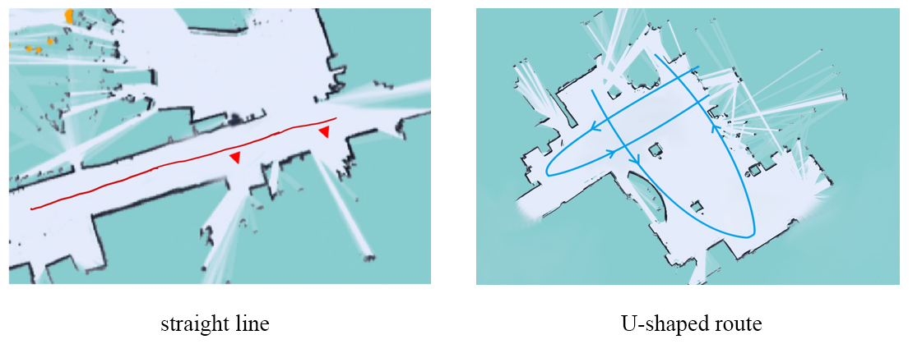

- When controlling the machine to move, you need to pay attention to whether the laser matches the actual terrain. If it does not match, stop and wait for a while until the laser matches the actual terrain before continuing. As shown below:
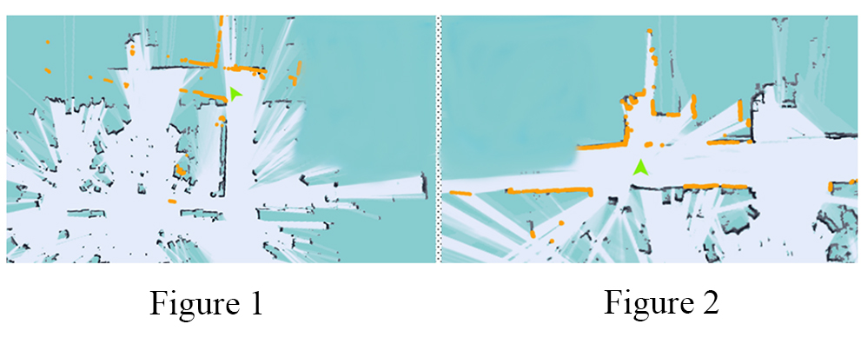
Figure 1: The laser does not match the terrain (when the laser does not match the terrain, you must stop and wait for the laser to match the terrain before continuing to push the robot to map)
Figure 2: Laser and terrain matching (some areas require the robot to turn around to scan clearly, such as wide terrain and rooms)
- Do not move the machine after it reaches the end point. Just observe whether the map is clean and clear of ghosts and matches the actual terrain. If there is no obvious misalignment, you can click "Composition Complete". If there is misalignment, please wait for a while. Algorithm Corrections will be made. If correction is not successful within 10 minutes, consider rebuilding the map.
Precautions:
1. When controlling the robot, always observe whether the laser matches the terrain. If a mismatch occurs, you need to stop and wait for the laser to match the current terrain.
2. After the robot reaches the end point, observe whether the map is clean and free of ghosts and matches the actual terrain. If there is no obvious misalignment, you can click "Composition Complete". If there is a misalignment, please wait for a while and the algorithm will correct it. If correction is not successful within 10 minutes, consider rebuilding the map.

Step 3 [Edit Cleaning Area]
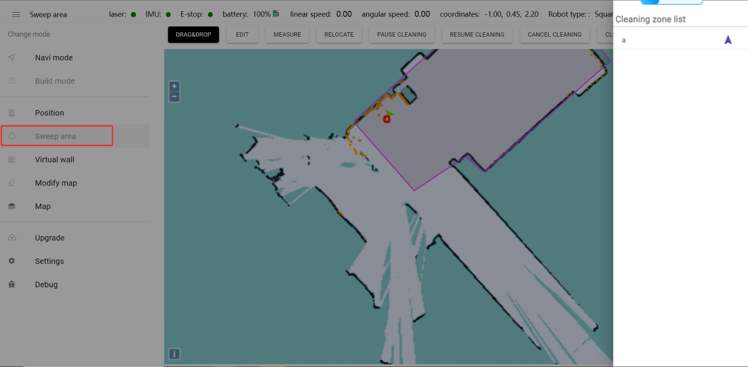
EDIT: Use polygons to draw out the areas that need cleaning
Measure: measuring distance
Cleaning zone: Click to pop up all edited cleaning areas

Step 4 [Edit Virtual Wall]
The function of editing the virtual wall: restricting the robot’s activity area
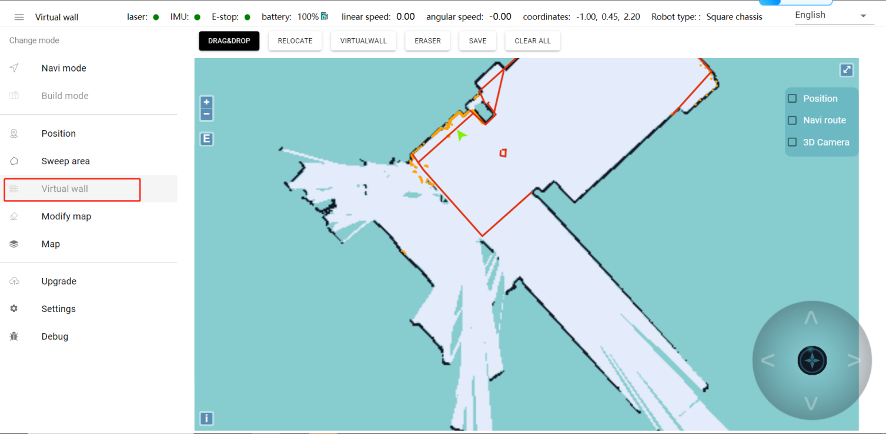
Drag & drop: This mode allows you to zoom, pan and rotate the map. In this mode, press "ctrl+left mouse button" to select a rectangular area, and the virtual walls in this area will be cleared.
Virtualwall: connect two points to form a straight line, often used for regular terrain or rough drawing of an approximate area.
Eraser: Clear the selected portion of the virtual wall
Save: Only when you click Save will the drawn virtual wall be stored.
Clear all: Clear all virtual walls (you need to click Save to take effect)

Example: glass wall
Note: Laser can penetrate glass, so when drawing a virtual wall, you need to pay attention to drawing the virtual wall outside the glass.
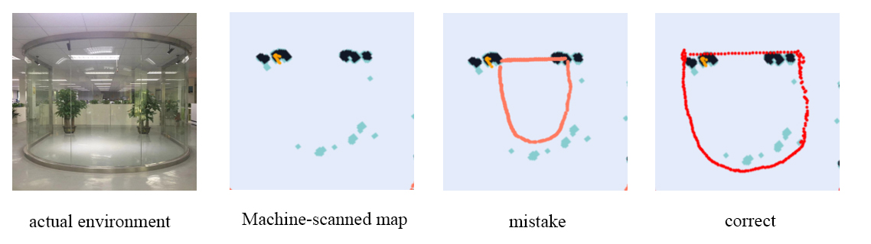
Example: table
Note: The laser can only scan a horizontal plane, so consider the desktop protrusion when drawing the virtual wall

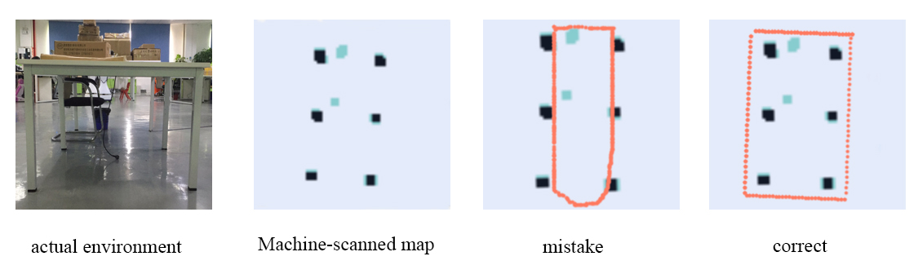

Precautions:
- The minimum passing distance of the machine is 1.5m, so you need to pay attention when drawing the virtual wall
- The main function of the virtual wall is to draw the robot's activity space and separate areas where the robot does not want to travel with virtual walls.
- Please be sure to create virtual walls for areas that do not require driving or areas that cannot be scanned by lasers (glass walls, tables, chairs, steps, light-transmitting and fragile items, etc.).

Step 5 [Calibrate position]
The role of calibration location: providing reachable target points for business layer applications
Note: The calibrated position must be at least 50 cm away from surrounding obstacles and virtual walls; the "charging pile" or "charging_pile" in English must be marked on the map; the machine will perform relocation when the machine is turned on within 2m of the charging pile.
Schematic diagram of charging pile calibration method:
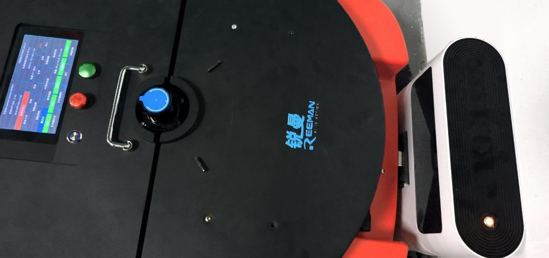
First, move the machine so that the charging spring of the machine is facing the charging spring of the charging pile, then click the "Charging Pile" button on the map menu bar.
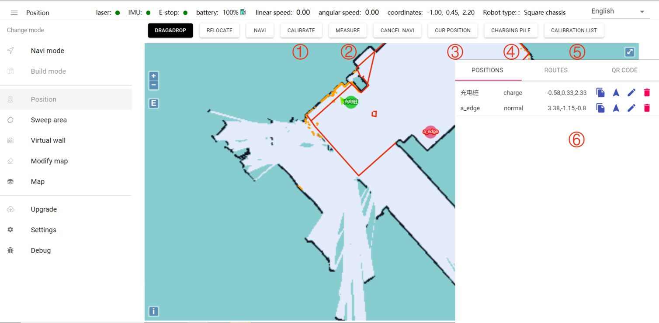
①Punctuation: You can drag on the map to get the coordinates of the specified location for calibration.
②Distance measurement: Click any two points on the map to get the length of the driving route
③Current position: The current position of the robot can be obtained for location calibration.
④Charging pile: Place the charging shrapnel of the robot facing the shrapnel of the charging pile, and then click "Charging Pile" to calibrate. The icon will automatically move forward during calibration (Note: This is the only exception)
⑤Calibration list: Click on the right side of the screen to pop up ⑥the "location list" and "route list"

Step 6[Cleaning along the edge]
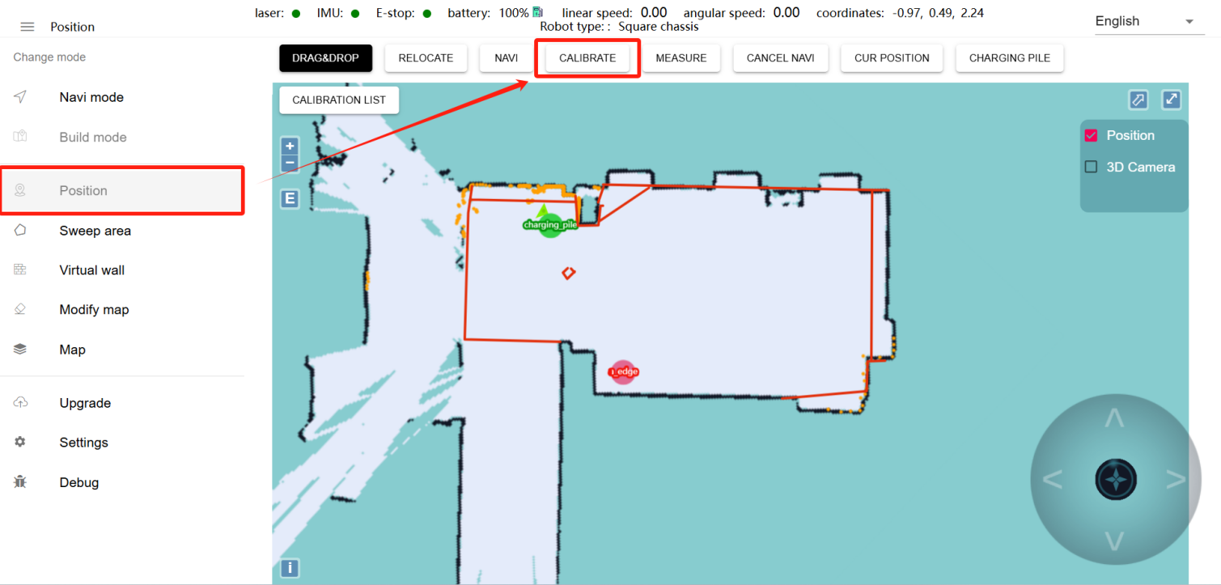
Calibrate edge points: The name of the cleaning area is: a. Under "Position", the robot is 1.5 meters to 2 meters close to the edge of the cleaning area, and the positive direction of the robot should be towards the wall of the cleaning area or the edge of the cleaning area. After placing the position, click "Current position" and set the route point type, named "a_edge"

Precautions:
1. When calibrating the position, be sure to ensure that the current positioning of the machine is correct.
2. The calibrated position must be at least 50 cm away from surrounding obstacles and virtual walls.
3. Edge point naming requirements: Clean area_edge

D. Start cleaning tasks
Note: Before using this function, you need to deploy the map according to the previous steps.
Open the "Cleaning Robot" APP on the Android screen and you will enter the following interface. The following picture shows the interface description:
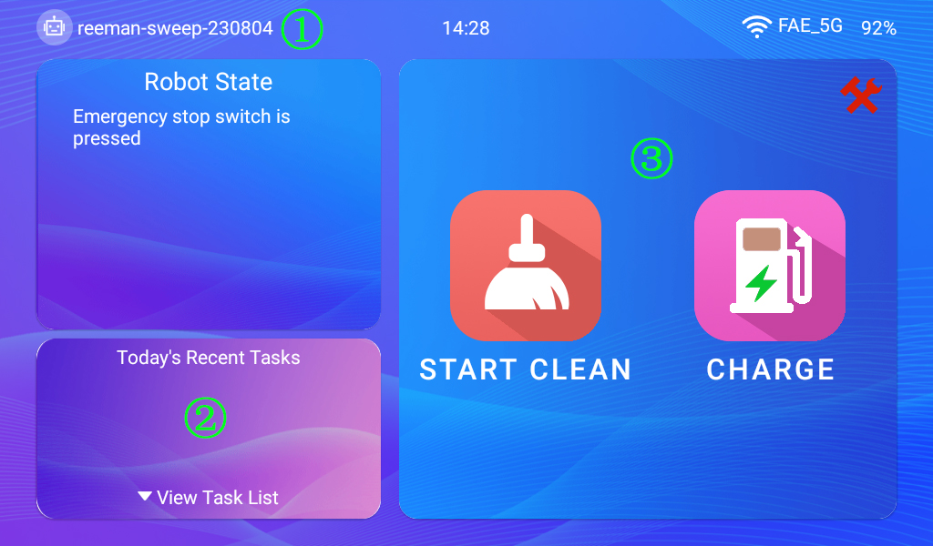
①Click the machine number to enter the "Settings" interface
②Click to enter the " Cleaning Plan Settings " interface
③Click " Start Cleaning" to enter manual cleaning mode

Setup instructions
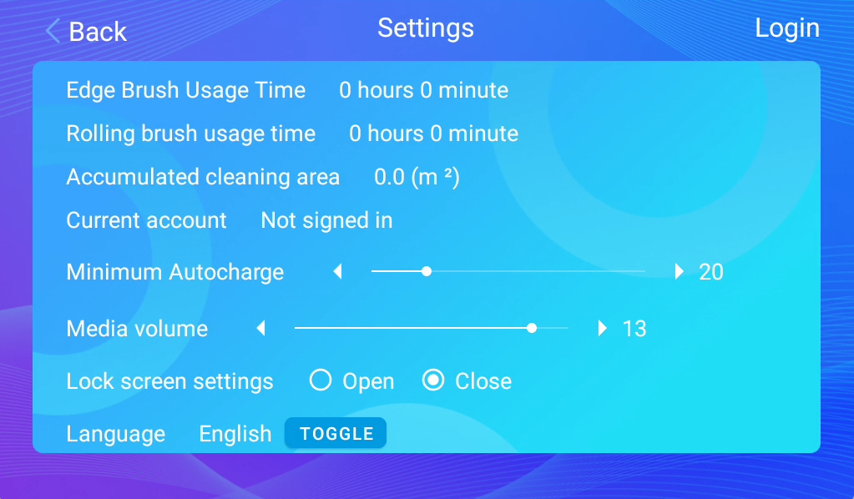
Side brush service life：the cumulative working time of the side brush
Roller brush service life：the cumulative working time of the roller brush
Cumulative cleaning area：Cumulative cleaning area of ​​the robot
Current account：Users can use login as their own account and password
Automatic charging：When the battery level is lower than the set value, the robot will be triggered to automatically recharge.
Media volume：Adjust the volume(Note: You can ignore this function for now, as the robot has not yet added a speaker.)
Lock screen settings：Users can choose whether to enable the lock screen state according to their own usage to prevent accidental touches.
Current language：You can switch to other languages.

Cleaning plan setting
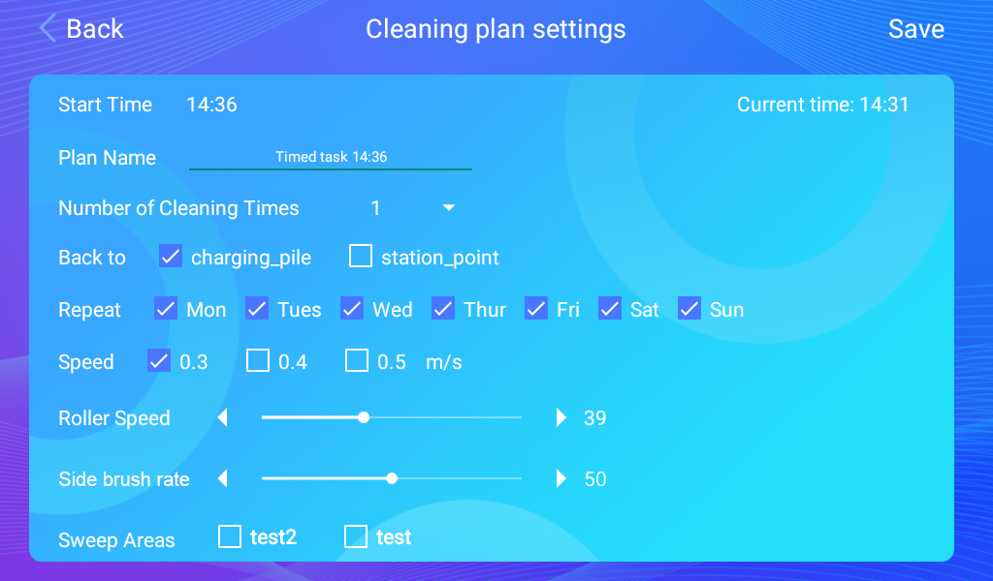

Plan time: Set the start time for the plan
Plan name: Give the plan a name
Number of cleanings: Set the number of times to be cleaned for the plan.
Return location: After the work is completed, go back to recharge or to the maintenance station (the maintenance station refers to the machine dustbin cleaning point)
Repeat time: the time of the scheduled cycle
Cleaning speed: machine travel speed
Roller speed: the speed at which the mopping module rotates
Side brush speed: the speed at which the side brush rotates
Clean area: Click to select the area to be cleaned

Swipe right to open the settings interface
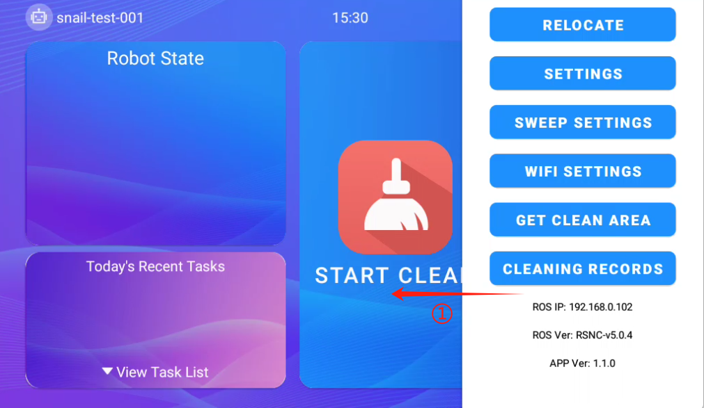

Repositioning：If the robot loses its position, push the robot back to the charging station and click Reposition to correct the position.
Settings：You can enter the settings interface
Cleaning settings：The relevant parameter configuration for manual cleaning is roughly the same as that in the cleaning plan setting.
WiFi Settings：Can switch between different WiFi connections
Get Clean Area：Get/update the clean area and cache it locally
Cleaning records：View robot work records
①Swipe right to the settings interface to view the navigation IP, navigation version and application version

Start manual cleaning

Start cleaning: Click 'Start Cleaning' and a cleaning area selection box will pop up. Select the area to be cleaned and click OK to start cleaning.
Return to charging: Click 'Return to charging' and the machine will immediately return to the charging pile for charging.

3. Explanation of other functions

a[Modify Map]
Tip: No need to skip this step
Prerequisite for editing the map: If an obstacle is missed during the scanning process, or the map has changed after the scanning is completed, and the change is not significant, you can use the edit map function to edit the map appropriately. If the map is too different from the actual environment, it is recommended to scan the map again.
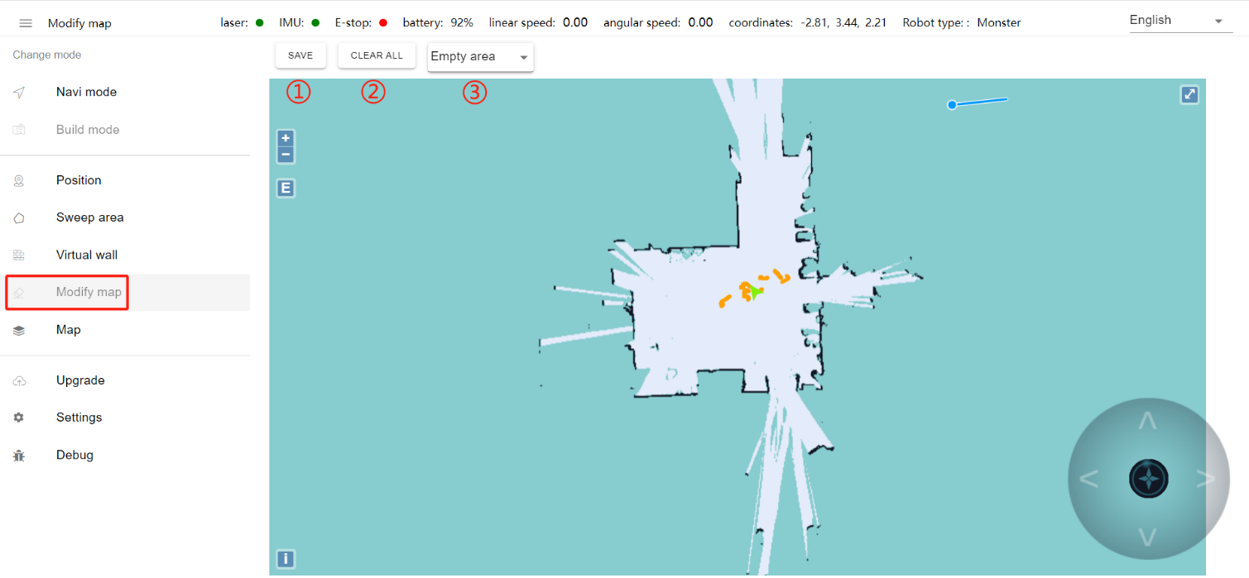
- The changes to the map will be applied only after clicking Save.
②Clear the drawn polygons
③Here is the drop-down menu, you can choose different map area types
- Blank area: Remove noise points (such as noise points left on the map by pedestrians walking by during the map scanning process and temporary obstacles, etc.). Do not remove real obstacles as noise points.
- Obstacle area: Some real fixed obstacles may not be scanned very clearly when building the map. Obstacles need to be manually drawn on the map (note that the obstacles drawn must match the obstacles that can be scanned by real lasers. ).
- Unknown areas: Some frequently changing feature points need to be drawn as unknown areas (such as areas where robots cannot walk outside glass walls).
④The inside of the drawn polygon is the modified area

b[Map Management]
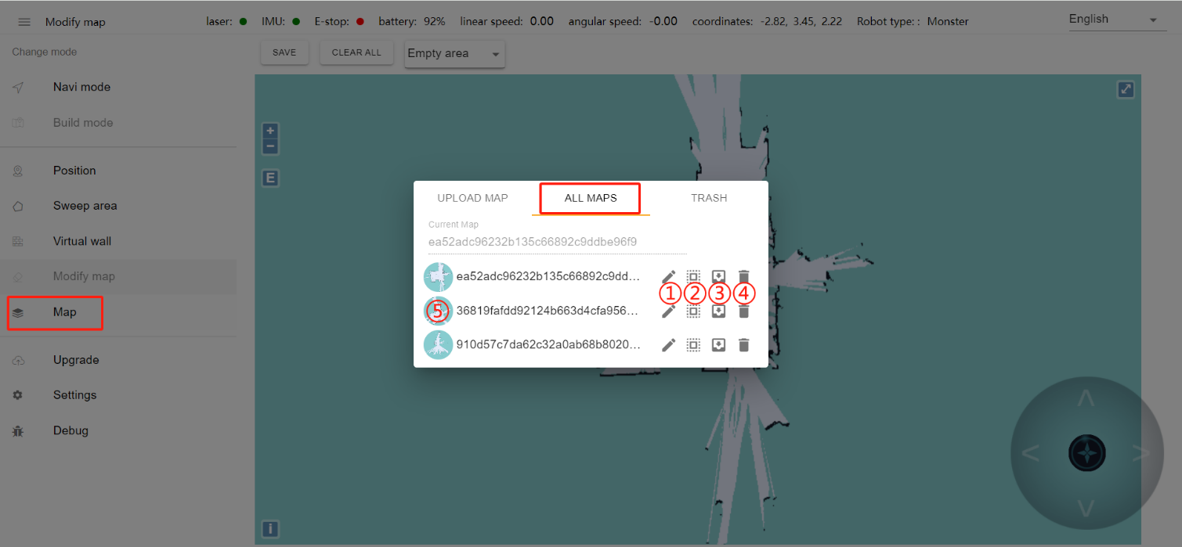
① Modify the map name ② Apply this map ③ Export this map ④ Delete this map
⑤Hover the mouse to display the preview map, click to display the original map

c[Upgrade]
Tip: We will upgrade the machine to the latest version before it leaves the factory. If you need to update the version later, follow the steps below.

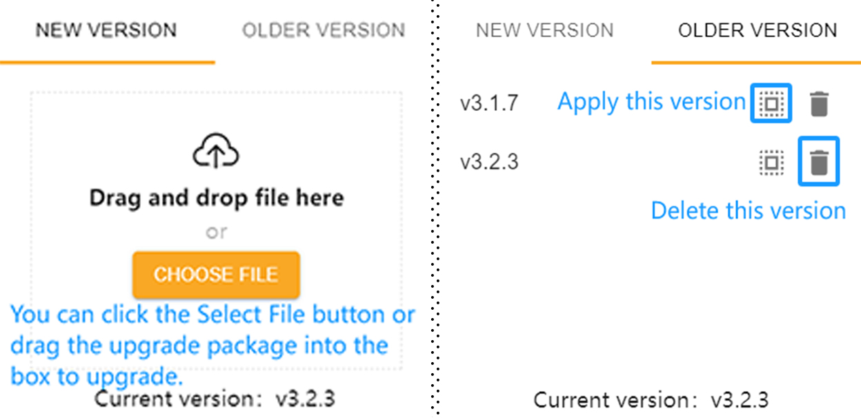

d[Settings]
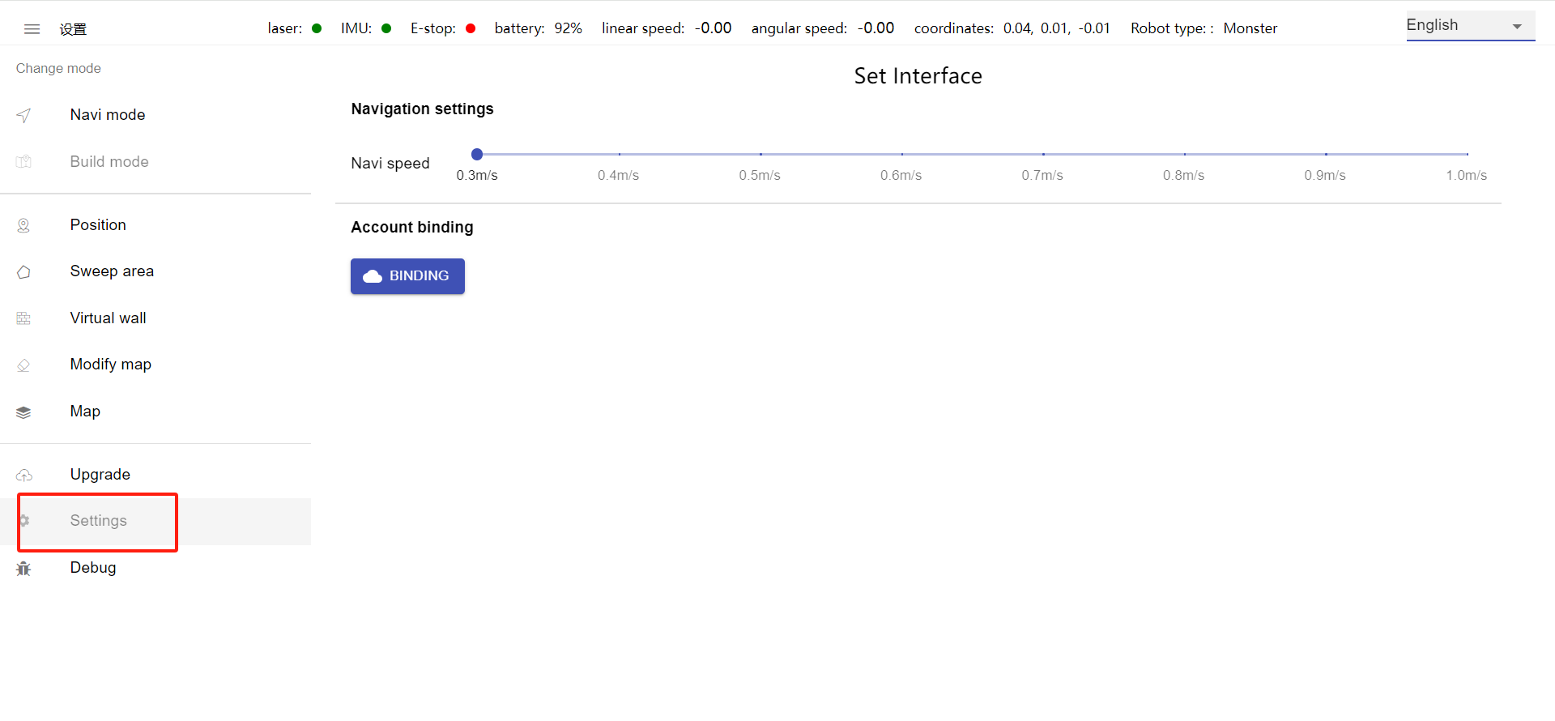
Navigation speed: adjust the driving speed of the machine (unit: m/s)

4. Daily maintenance of robots
Each robot has a certain lifespan. If it is not properly maintained during use, the lifespan of the robot may be shortened. It will also affect the use effect and even cause hardware damage. The following describes how to use and maintain cleaning robots in daily work .

- Open the dust bin of the cleaning robot
How to open: There is a folding handle directly above the machine as shown in the picture below. Pull the handle and the upper dust box of the machine will open.
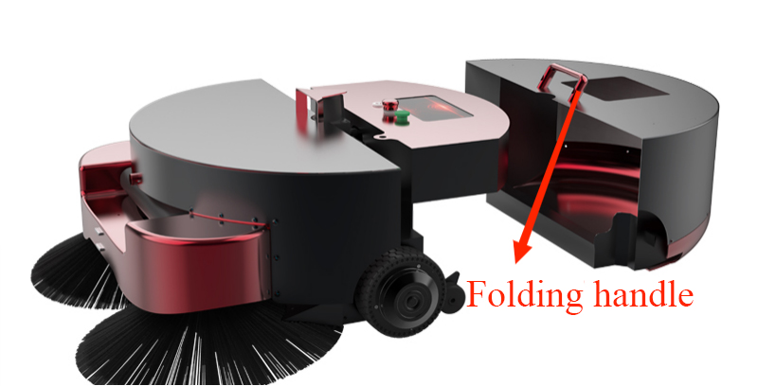

1. LiDAR
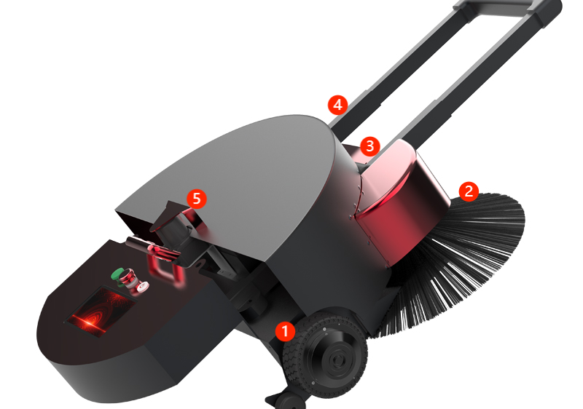
Pay attention to the machine lidar not to be contaminated with dust or scratches, which will cause noise problems during laser mapping.

2. Dust cleaning
The machine wheel bearings, machine roller brushes, side brushes and the wires inside need to be cleaned regularly from dust. The machine charging shrapnel and infrared lens also need to be cleaned regularly from dust to avoid excessive dust that may cause the machine to fail to connect to the charging pile.

5. Precautions for daily use

① Machine positioning is lost
Overview: Positioning loss refers to the mismatch between the robot's map position and the actual environment position.
Cause of:
- Positioning loss caused by manually pressing the emergency stop switch to move the machine
- During the movement, the robot will match the current map based on the actual laser data. If the current environment is too different from the map, the robot will fail to match the map, resulting in loss of positioning. Loss of positioning will cause the robot to lose its path planning ability and be unable to move.
- If someone surrounds the machine in front, the positioning will be lost. If many people surround the machine, the laser will be blocked. The matching between the laser and the terrain will become very low, causing the positioning to be lost.

Solution:
- aging-ros3 application on the screen , enter the IP address displayed in the IP column of the navigation system in the browser, enter the machine background, and manually relocate the machine.
- Move the machine to the charging pile and restart the machine within 2m of the charging pile (note: the target point of the charging pile must be marked on the map)

② The machine does not navigate
Overview: The machine does not navigate means that the machine navigates to a certain point and the machine does not move.
Cause of:
- Check whether the machine's emergency stop switch is turned on. Only when it is turned on can the machine navigate autonomously (turn the emergency stop switch to the right to turn it on, and press it to turn it off).
- Check whether the machine has lost its positioning (the orange laser and black obstacles on the map do not completely overlap, indicating that it has lost its positioning)
- Check whether the machine is close to obstacles or virtual walls (machine being close to obstacles or virtual walls will cause the machine to be unable to navigate)
- Check if the target point is close to an obstacle or virtual wall

Solution:
- If the positioning is lost, follow ①Solution to machine positioning loss to reposition the machine.
- When the machine is close to an obstacle or virtual wall, move the machine outward a little
- Reset the target point when the target point is close to an obstacle or virtual wall. When setting, it should be about 50cm away from the obstacle or virtual wall.

③ The machine navigation does not respond when charging.
Overview: Send navigation charging instructions to the machine but the machine does not start navigation.
Cause of:
- Check whether the calibration of the charging pile point is done by using the charging pile button after the machine is connected to the charging pile.
- Check whether the charging pile target is close to obstacles or virtual walls
Solution:
- Please refer to [Calibration Location] for the calibration method of charging piles.
- There should be no obstacles within 1.5m on the left and right sides of the charging pile.

